When AI Stops Generating and Starts Building
A survey of 259 works reframes creative AI as stateful construction — and asks when the extra control is worth it
Ask a modern generative model for a poster, a working program, or a game level, and it will hand you something in seconds. That fluency hides a stubborn gap: a plausible-looking draft is not the same as a finished, dependable deliverable. A poster can have the right colors but the wrong hierarchy; a program can compile but fail a test; a 3D scene can render but collide with itself. These artifacts are hard precisely because their requirements interact, and a single quality score cannot certify that all of them are met at once.
A new survey argues that the field is quietly shifting to meet this challenge — moving from one-shot generation toward what the authors call agentic artifact creation: a system that materially builds a deliverable step by step and lets what it observes along the way redirect the work still to come. Reviewing 259 works (230 systems and 29 benchmarks) through August 2026, the paper offers a shared definition, a functional architecture, a tour of six artifact families, an audit of how the field evaluates its systems, and four cross-cutting design principles.
The paper is a survey rather than a single new system, so its contribution is conceptual: a vocabulary and a set of principles for reasoning about a fast-growing but fragmented literature. It comes with an open, curated repository and a project website tracking the field.
Figure 1. From direct generation (top) to agentic creation (bottom). Direct generation follows a fixed schedule where intermediate observations cannot redirect later actions, so problems surface only at final inspection. Agentic creation couples a construction policy, an operational representation, and runtime verification so feedback can steer decisions before the artifact is accepted.
Paper: https://arxiv.org/abs/2608.28122
Code / curated list: https://github.com/GeminiLight/awesome-agentic-artifact-creation

The problem with one-shot generation
Direct generation follows a fixed, one-way schedule: the model commits to a plan and produces the output, and only a final inspection reveals whether it worked. When a deliverable is governed by several interacting acceptance criteria, the authors argue this pattern creates three recurring failures. Problems propagate through the whole artifact instead of staying local. When something is wrong, it is hard to localize which decision caused it. And because the output is monolithic, repair often means regenerating large parts rather than fixing one flaw.
This is not an argument against direct generation everywhere — it works well for bounded tasks that are cheap to inspect and easy to redo. The trouble appears when accepting a deliverable requires satisfying many coupled requirements that no single scalar score can certify.

A functional architecture for building, not just generating
The survey's central move is to define agentic creation precisely, so it can separate genuinely stateful builders from generic problem-solvers. In their definition, an episode counts as agentic creation when the system carries artifact or process state across decisions and uses at least one intermediate observation to redirect later work. That stateful-construction boundary is the screening rule used to include or exclude the 230 systems.
Underneath the variety, the authors find three recurring roles. An operational representation exposes the artifact's current state plus an edit interface for changing it. A construction policy chooses the next action given the task, the current state, and any feedback. And runtime verification observes the updated state, checks it against acceptance criteria, and either releases the finished artifact or feeds back a signal that informs the next revision. Policy, edit, and verification repeat until the work is accepted or the system stops.
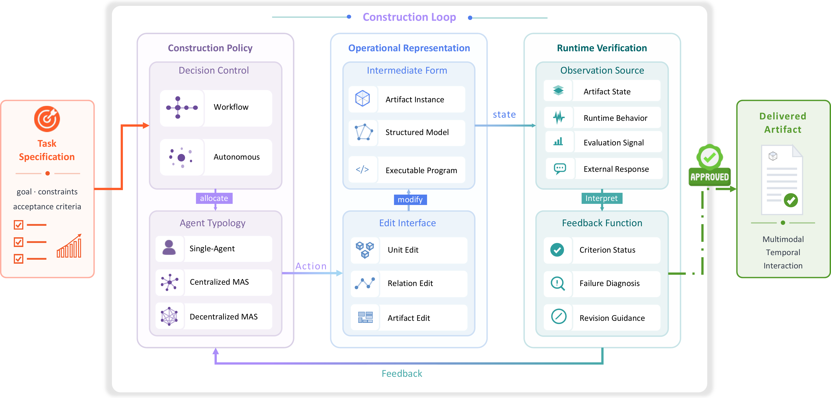
Figure 4. The functional architecture. A task specification drives decision control; actions modify an intermediate form through the operational representation's edit interface; runtime verification turns observations into feedback that returns to the construction policy — unless acceptance releases the delivered artifact. The component interiors list recurring, non-exclusive ways each role is realized.

Six families, one shared question: when do failures show up?
The survey groups the literature by the primary artifact form into six families: textual, 2D visual, audio, video, spatial (such as 3D scenes), and behavioral (such as agents and game logic). Behavioral artifacts form the largest family with 73 systems. Rather than treating each family as a separate world, the authors read them through one lens: where and when does a failure become observable, and is it still repairable when it does?
That question cuts across modality. Some artifacts reveal flaws under static inspection — you can look at text or an image and see the problem. Others only expose failure during temporal playback, as with audio and video. And some surface problems only as runtime consequences, when a spatial scene is simulated or a behavior is executed. The later and less legibly a failure appears, the more explicit control tends to pay off.
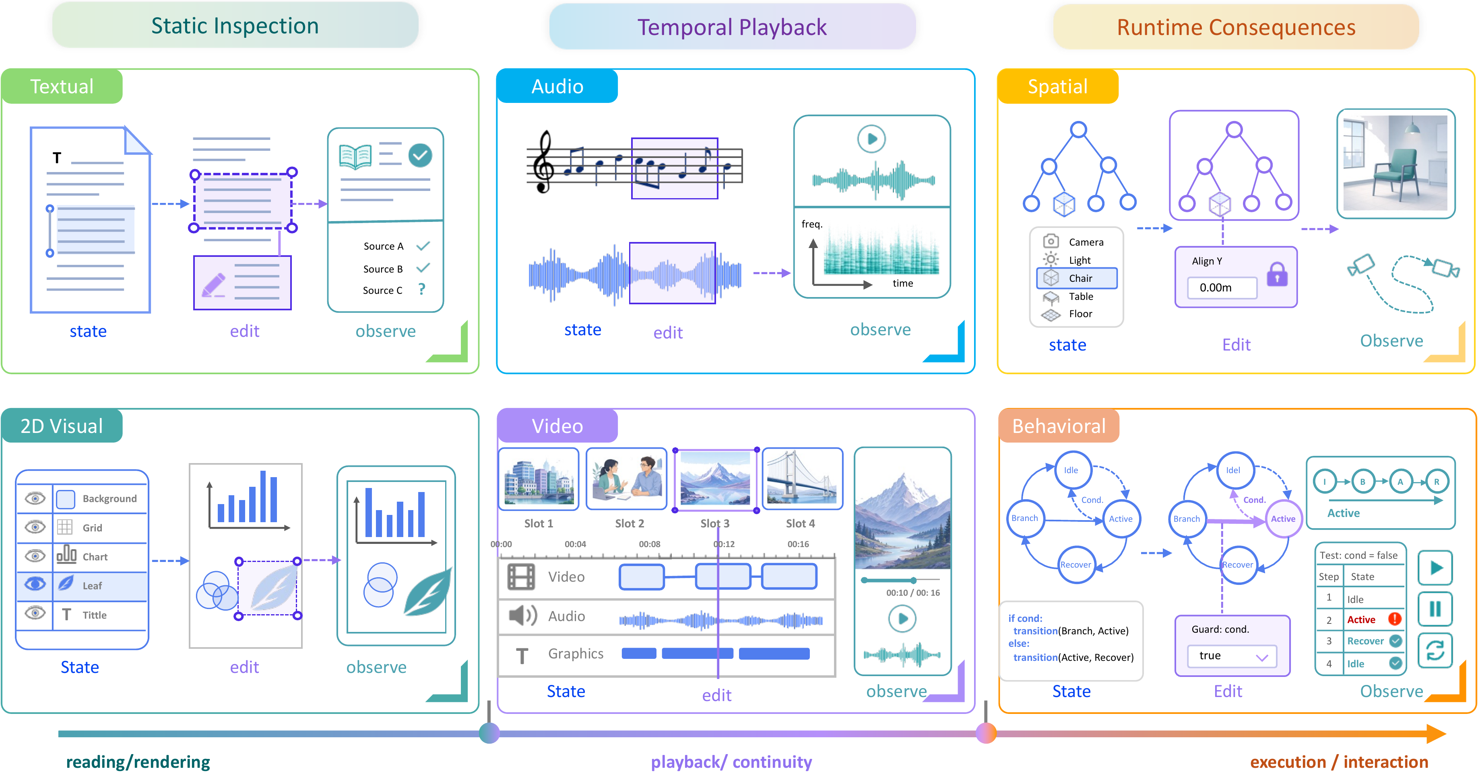
Figure 5. An observability landscape for the six artifact families. Each vignette follows a shared state–edit–observe grammar, and the columns mark where failures typically become visible: static inspection for text and 2D visuals, temporal playback for audio and video, and runtime consequences for spatial and behavioral artifacts. These are tendencies, not strict rules.

What the evidence actually supports
Two findings temper the enthusiasm. First, decomposition — the standard tactic of breaking a hard build into smaller steps — reduces local complexity but raises the cost of coordinating and reassembling the pieces; it is a trade, not a free win. Second, learned judges (models trained to score outputs) can add little independent evidence when they share the generator's blind spots, effectively grading the work with the same errors that produced it.
The evaluation audit is the sharpest part of the paper. Across the surveyed benchmarks, only three protocols evaluate any system property beyond raw task capability — and each of those covers just one such property. Reporting of calibration, disagreement, tool use, budgets, stopping rules, and cost is inconsistent, which makes fair comparison hard. Even aggregate arena scores can mislead: a single leaderboard rank can hide large task-specific differences in how models actually stand relative to one another.
Table 1. The survey at a glance (through August 2026).
Dimension | Count
Works reviewed | 259
Agentic systems | 230
Benchmarks | 29
Artifact families | 6
Largest family (behavioral) | 73 systems
Benchmarks testing beyond task capability | 3
Synthesized design principles | 4

Four principles — and when the complexity is worth it
The survey distills its reading into four design principles for keeping control coherent as artifacts evolve: externalize commitments into addressable state, define control boundaries by dependencies and consequences, make feedback actionable toward bounded repair, and revalidate any state that a change affects. They are offered as a qualitative lens, not a sequential pipeline or a maturity ladder.
Figure 10. The four principles of agentic creation. A qualitative lens identifies tasks that benefit from stronger explicit control, connecting criteria to state, consequences to responsibility, evidence to repair, and change to revalidation — all around addressable artifact state. The relations are qualitative, not a fixed sequence.
The honest bottom line is a boundary condition. Agentic construction earns its added complexity only when observations improve later decisions enough to justify the cost of the control machinery; its real value lies in bounded revision and in preserving state that has already been accepted, not merely in generating drafts. When there is little accepted state to protect, plain direct generation still wins. As a survey, the paper maps the terrain and names the trade-offs rather than crowning a single best system — which is exactly what a young, fragmented field needs before it can compare itself honestly. The practical upshot for builders is a checklist rather than a recipe: decide what state must be preserved, expose it so it can be addressed, verify at the moments failures actually become visible, and re-check only what a change can plausibly break. Read that way, the four principles are less a manifesto than a set of questions to ask before reaching for a more elaborate agent — and a reminder that the goal is not more control for its own sake, but proportionate control that a team can inspect, trust, and account for as intent and systems keep shifting.

