Don't Copy the Whole Teacher: Fixing Only Where a Tool-Calling Agent Goes Wrong
DART-SD reframes agent distillation as topology-guided localized correction — and its compact students end up beating the larger teachers they learned from.
The usual recipe for teaching a small language model to use tools well is imitation: let a large "teacher" model solve a task step by step, record the whole trajectory, and train the smaller "student" to reproduce it turn for turn. It is simple, and for single-step problems it works. But real agent tasks rarely have a single correct order of operations.
Consider a task with several independent sub-goals — book a flight, reserve a hotel, rent a car. Any ordering is valid, so the set of correct solutions is not one line but a lattice of interchangeable paths. The authors of DART-SD call this the diamond topology of the solution space. Force that rich structure into a single linear trajectory and you get what they term topological collapse: the student is penalized for taking a correct-but-different path, its exploration is overwritten, and its policy diversity is destroyed.
DART-SD — Diamond-topology Aware Retrieval and Tuning for Self-Distillation — comes from a team at ByteDance and the University of Science and Technology of China. Its core idea is a small shift with large consequences: instead of supervising the entire trajectory, find the exact point where the student first leaves the recoverable region and correct only the steps after it, leaving the valid reasoning it already produced untouched.
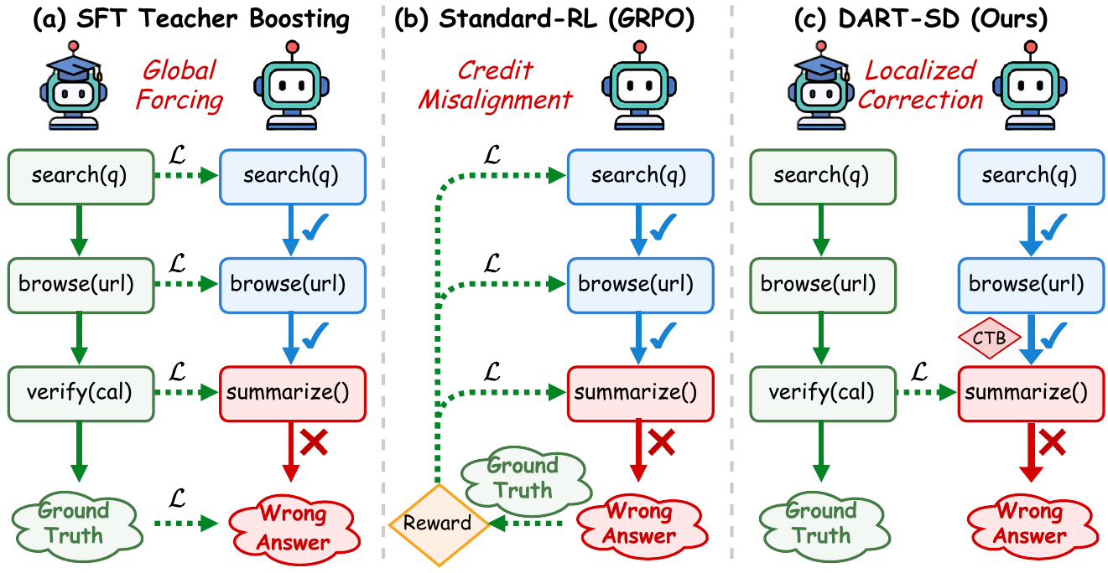
Figure 1. Three ways to train a tool-calling agent. (a) SFT teacher boosting applies one global loss that overwrites valid exploration. (b) Standard RL (GRPO) spreads reward uniformly and misassigns credit. (c) DART-SD locates the Critical Topological Breakpoint (CTB) and corrects locally while preserving valid exploration.
Paper: https://arxiv.org/abs/2608.18524

The problem: global loss punishes harmless detours
The paper argues that every prevailing training paradigm mishandles the structure of exploration in the same way — it cannot tell a fatal mistake apart from a harmless detour. Supervised fine-tuning with teacher boosting applies a single global loss across the whole trajectory, so a valid exploratory tool call gets overwritten just because the teacher happened to do something else. Reinforcement learning methods such as GRPO spread a single episode-level reward uniformly across all steps, misassigning credit so that good intermediate calls are punished alongside bad ones.
Earlier "hindsight" methods that try to relabel or repair failed attempts still treat an interaction as a strict linear sequence. That linearity is the root issue: it conflates the one step that actually doomed the attempt with all the exploratory steps that were fine. The missing ingredient, the authors say, is a principled way to locate where the student truly went wrong and correct only from there.

The method: model the run as a graph, then find the breakpoint
DART-SD builds its correction on an explicit model of the interaction. Tool responses are first abstracted into information atoms — the discrete pieces of information a call actually yields — and each state of the run is mapped onto an Interaction-State Transition Graph (ISTG). The graph has main nodes for genuine information acquisition and auxiliary nodes for useless exploration, and it captures the diamond topology of successful and failed paths in one structure.
From the teacher's successful runs, the method defines a budget-filtered success-reachable region: the set of states still close enough to a solution, within a task-specific reachability budget, that recovery is realistic. When a student's own rollout fails, each of its states is projected onto this region by type. The first transition from a projectable state to a non-projectable one is the Critical Topological Breakpoint (CTB) — the precise moment the student left the recoverable zone.
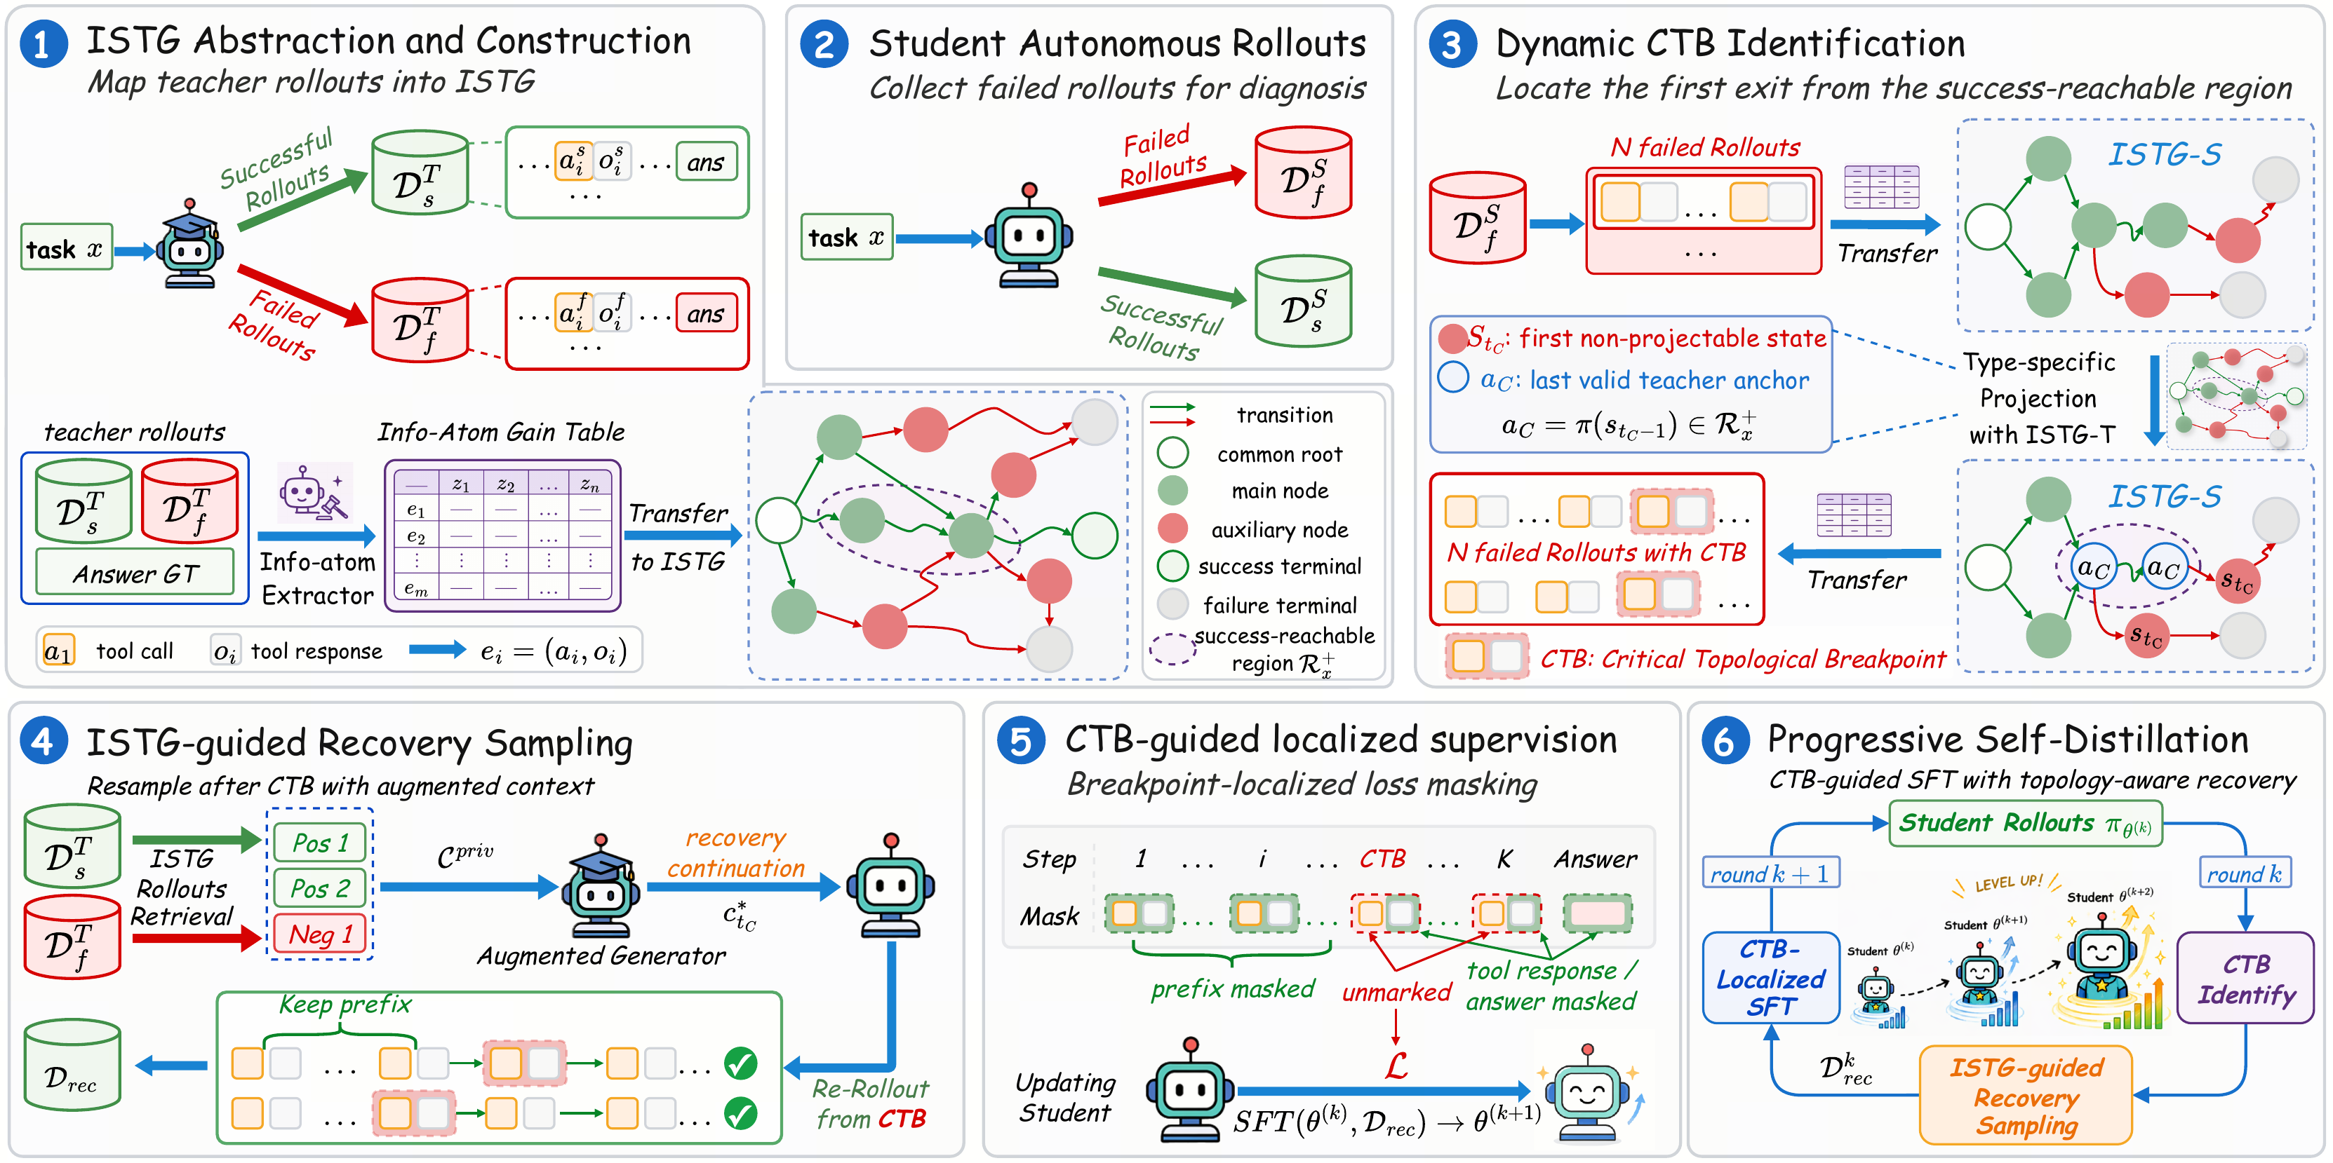
Figure 2. DART-SD overview. (1) An ISTG is built from teacher rollouts, with main and auxiliary nodes. (2-3) Failed student rollouts are replayed in the same state space and projected onto the budget-filtered success-reachable region; the first projectable-to-non-projectable transition marks the CTB. (4-5) Conditioned on the retained student prefix and privileged teacher references, DART-SD generates a recovery continuation after the CTB and supervises only the newly generated assistant tokens. (6) The loop repeats across self-distillation rounds.
Correction then happens only past that breakpoint. An augmented generator, conditioned on the student's retained prefix plus privileged teacher references, produces a recovery continuation from the CTB onward. A masked causal language-modeling loss is applied to those post-breakpoint assistant tokens only — the mask zeroes out the valid prefix so gradients never touch the reasoning the student already got right. The single objective is L_DART = -Σ mᵢ log p_θ(ỹᵢ | ỹ_<i, x), where the mask mᵢ selects only the recovery tokens.
Because the ISTG is maintained per task across five self-distillation rounds, the whole process becomes a self-paced curriculum: as the student improves, the point where it first stumbles moves later in the trajectory. The authors measure this directly — the average CTB position advances from 0.348 to 1.452 over the five iterations, meaning the model holds a valid path for longer before it first departs from the recoverable region.

The evidence: compact students that outrun their teachers
Training uses FTRL, a dataset of more than 2,000 automatically constructed tool-use environments with verifiable feedback, spanning four task structures — Single, Para-Single, Multi, and Para-Multi. Students are Qwen3-4B and Qwen3-8B, distilled from a mixed teacher pool of Qwen3.6-27B and GLM-5.2. Evaluation covers five benchmarks: FTRL in-domain, plus four out-of-domain suites — BFCL, ToolHop, τ-bench, and RoTBench.
Across both backbones, DART-SD posts the best overall average, beating every distillation and reinforcement-learning baseline: 45.58 average with Qwen3-8B and 39.17 with Qwen3-4B. On the in-domain FTRL Solve-F1 metric, the 8B student nearly doubles its base score, from 23.48 to 45.66. The gains hold in-domain and out, which the authors read as evidence that topology-aware tuning learns transferable tool use rather than overfitting FTRL.
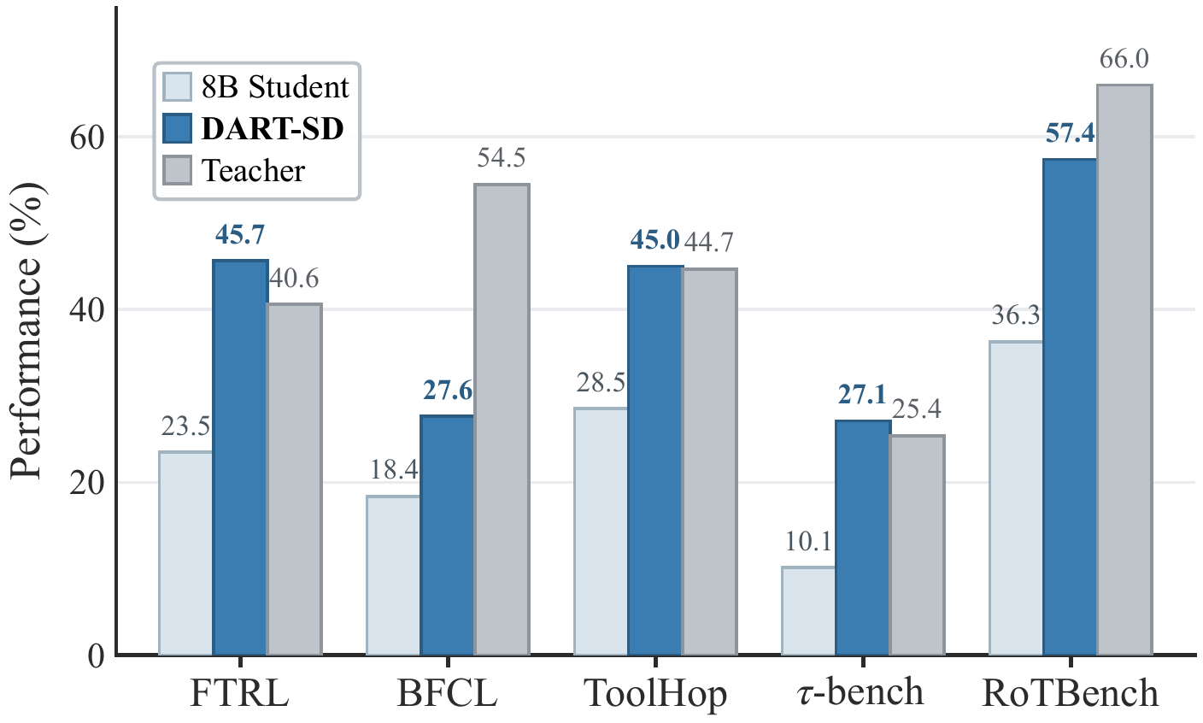
Figure 3. Qwen3-8B base, DART-SD, and the teacher across five tool-use benchmarks. DART-SD improves on the base model everywhere and surpasses the much larger teacher on FTRL, ToolHop, and τ-bench.
The most striking result is in that figure: on FTRL, ToolHop, and τ-bench the 8B student surpasses the teacher pool it was distilled from, despite being far smaller. Correcting only the recovery steps, it seems, extracts generalizable behavior a whole-trajectory copy would have flattened.
Table 1. Overall average across the five benchmarks (best per backbone in each row group). DART-SD leads both backbones; a few representative baselines shown.
Method | Qwen3-4B Avg. | Qwen3-8B Avg.
Base | 25.19 | 29.60
SFT (teacher boosting) | 37.62 | 41.64
FTRL-GRPO (RL) | 33.66 | 40.33
ToolRL (RL) | 29.91 | 39.94
DART-SD (Ours) | 39.17 | 45.58
Two more findings round out the picture. Efficiency improves alongside accuracy: over the five progressive rounds the average number of tool calls in successful trajectories falls from 4.23 to 3.55 — shorter even than the 4.02 of the golden reference traces. And general capability is preserved rather than sacrificed to specialization, with a general-ability average rising from 43.92 to 49.89.

Why the design choices matter: the ablation
A component ablation on Qwen3-8B (FTRL Solve-F1) shows each piece pulling its weight. The base model scores 23.48. Plain self-distillation lifts it to 38.10. Adding CTB-guided localized supervision reaches 39.51. Progressive self-distillation across rounds pushes it to 43.93. Finally, replacing an LLM-judge breakpoint detector with the topology-aware ISTG projection reaches 45.66. The last step is the point of the paper: locating the breakpoint by structural state projection, rather than by asking an LLM to guess, yields both more accurate breakpoints and supervision that is structurally compatible with the graph.

Takeaway and limitations
The lesson DART-SD offers is compact: don't force a student to copy an entire teacher trajectory. Find the exact point where it first leaves the recoverable region, correct only from there, and protect what it already got right. Modeling agent execution as a diamond-topology graph turns messy exploration into a self-paced curriculum of localized corrections, and the resulting agents are more efficient, more general, and on several benchmarks better than their teachers.
The scope is worth stating plainly. The gains are demonstrated on Qwen3-4B and Qwen3-8B students with a specific teacher pool, and the method depends on abstracting tool responses into information atoms and building a reliable ISTG — a modeling step whose difficulty will vary across tool ecosystems. The evaluation, though it spans five benchmarks, centers on tool-calling agents; how far topology-aware localized correction transfers to other multi-turn settings remains an open question. What the paper establishes is that the where of correction can matter as much as the how much.

