Can a Model Steer a Coding Agent? LoopArena Puts Runtime Control on Trial
A new benchmark isolates the outer-loop decision — what to tell a coding agent to do next — and finds today's best models get long tasks over the line only about a quarter of the time.
"Loop engineering" has quietly become one of the more practical ways to get real work out of coding agents. Instead of hand-writing every instruction, practitioners wrap an agent in a loop: after each round of work, something reads what happened, decides what the agent should do next, and either keeps going or stops. When one of these long runs succeeds, it feels like magic. When it fails, though, it is genuinely hard to say why.
That ambiguity is the problem a new benchmark called LoopArena — from Alibaba's DreamX team, with collaborators at BUPT, UNSW Sydney, and Data61/CSIRO — sets out to fix. Their observation is simple but sharp: a single end-to-end outcome blends together two very different abilities. One is the coding agent's raw skill at writing and fixing code. The other is the quality of the guidance steering it — whether the loop asked for the right thing at the right moment. Existing benchmarks score the whole agent system or narrow one-off actions, so the runtime control decision itself is never the thing being measured.
LoopArena makes exactly that decision the object under test. It fixes the coding agent, the tools, the environment, the budget, and the evaluator, and varies only the model doing the steering. In their framing, that steering model is the Controller — and the question becomes: how good is a given model, purely as a runtime controller, at guiding someone else's coding work to a successful finish?
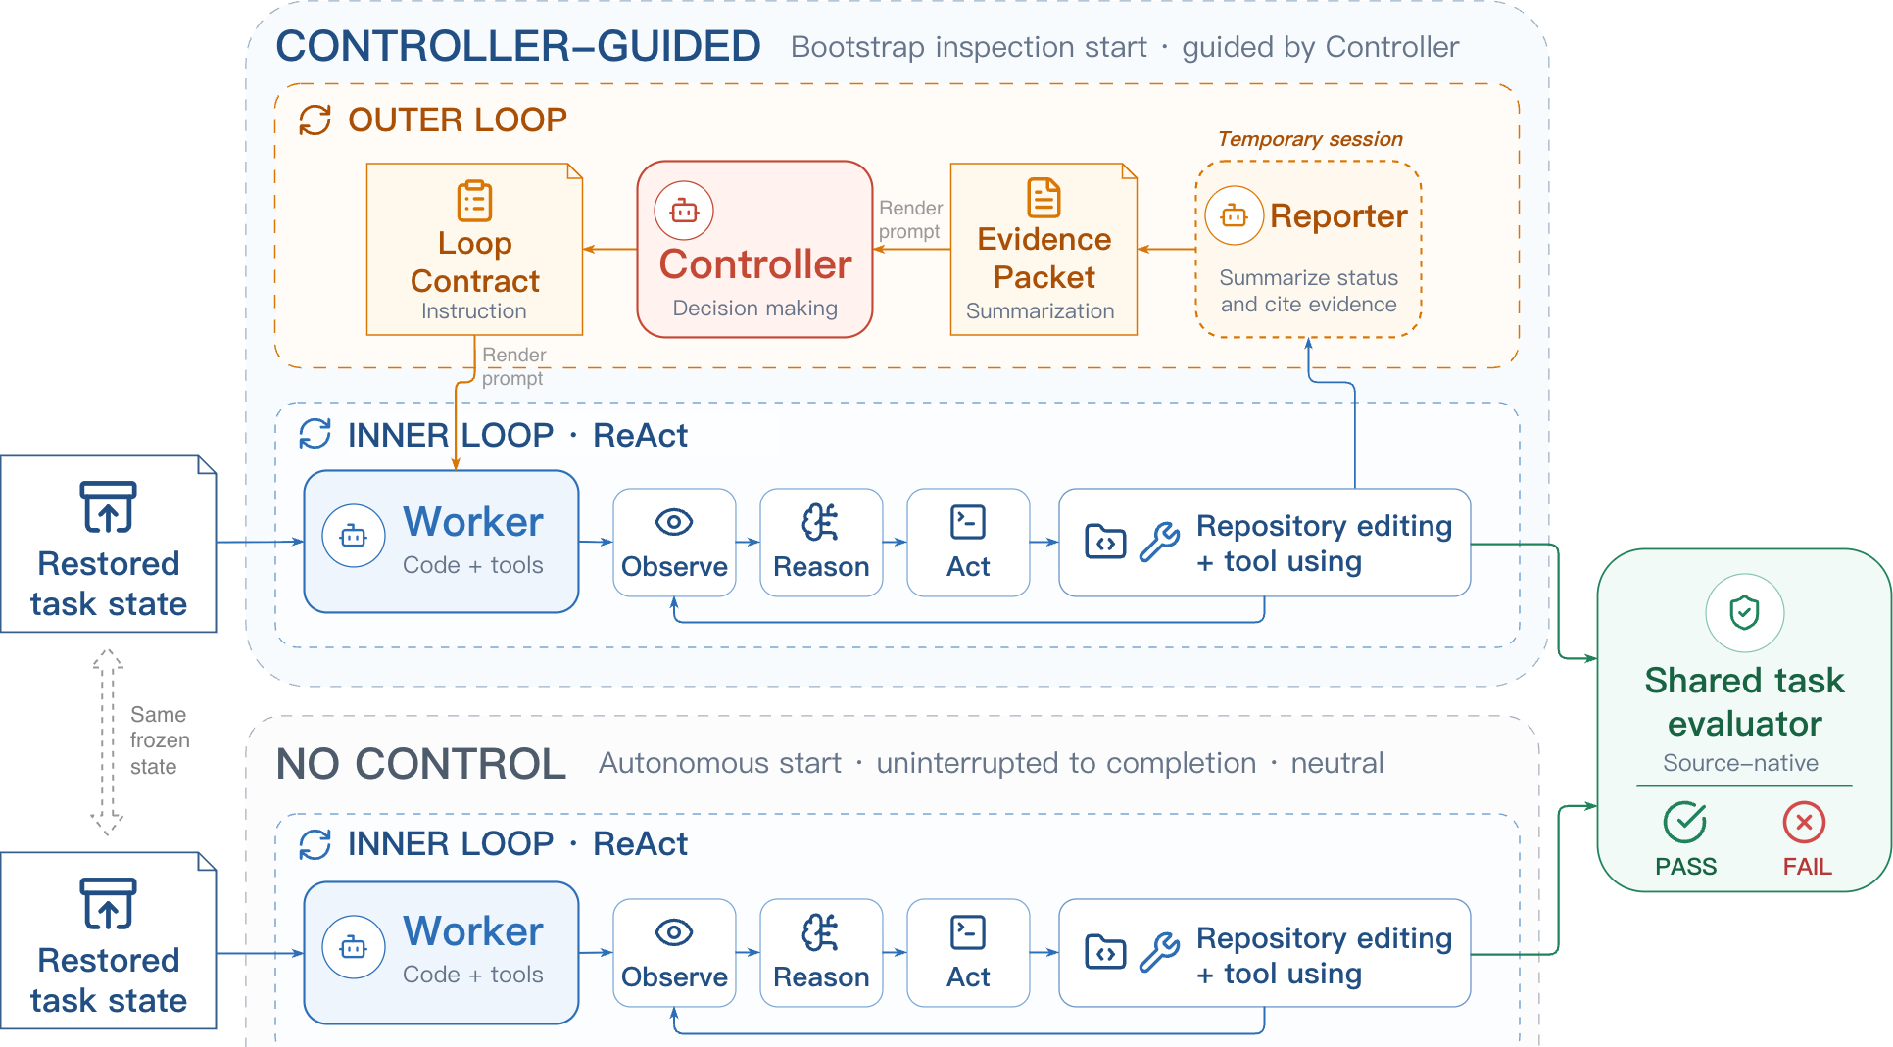
Figure 1. The LoopArena harness. Both conditions start from the same restored task state and share the same Worker, coding tools, and evaluator. In the Controller-guided condition, a temporary Reporter agent summarizes the Worker's progress each round, and the harness deterministically formats it into a read-only Evidence Packet. The Controller reads that packet and issues a Loop Contract that assigns the next Worker segment or decides to stop. In the no-control condition, the Worker runs on its own.
Paper: https://arxiv.org/abs/2608.28281 · Code: https://github.com/AMAP-ML/LoopArena

Why one number can't tell you what went wrong
Picture a loop that trusts a stale progress note and skips a verification step it badly needed, or one that burns its budget pushing in the wrong direction, or one that calls it done before the task is actually safe to submit. Each of these is a failure of control, not of coding. Yet in a normal end-to-end run they all collapse into the same signal: the task did not pass. You cannot tell the impatient controller from the incompetent worker.
Making this worse, the "right" next instruction is a moving target. Early on, a repository needs implementation. Later, a fragile piece needs verification. After a misstep, it needs recovery. And near the end, the winning move may simply be to stop before spending more budget. A good controller has to recognize which of these situations it is in — from evidence that keeps changing as the run evolves — and adapt. That is the skill LoopArena wants to measure directly.

How the harness separates control from coding
LoopArena runs a two-agent harness. A fixed Worker does all the actual coding through an inner Observe–Reason–Act loop — the same Worker for every model being tested. The Controller, the model actually under evaluation, is given no coding tools at all. It never touches the repository. Its entire job is to read a summary and decide what happens next.
The link between them is deliberately clean. After each Worker round, a temporary Reporter agent summarizes what the Worker did, and the harness deterministically formats that summary into a structured, read-only Evidence Packet. The Controller reads the packet and responds with a Loop Contract — a structured instruction that either assigns the next Worker segment or ends the run. Because the packet is read-only and the Worker, tools, budget, and evaluator are all held fixed, any difference in outcome traces back to one place: the Controller's decisions. Formally, each contract is c = π(h, Packet): the Controller's policy applied to the history and the current evidence.

Three settings that trade off cost and realism
The catch with evaluating long-horizon control is that running full tasks end-to-end is expensive. LoopArena addresses this by scoring control at three scopes, built from full coding tasks in two long-horizon suites, SlopCodeBench (SCBench) and BeyondSWE. The benchmark holds 90 Type I questions and 27 paired Type II / Type III task instances (11 from SCBench, 16 from BeyondSWE).
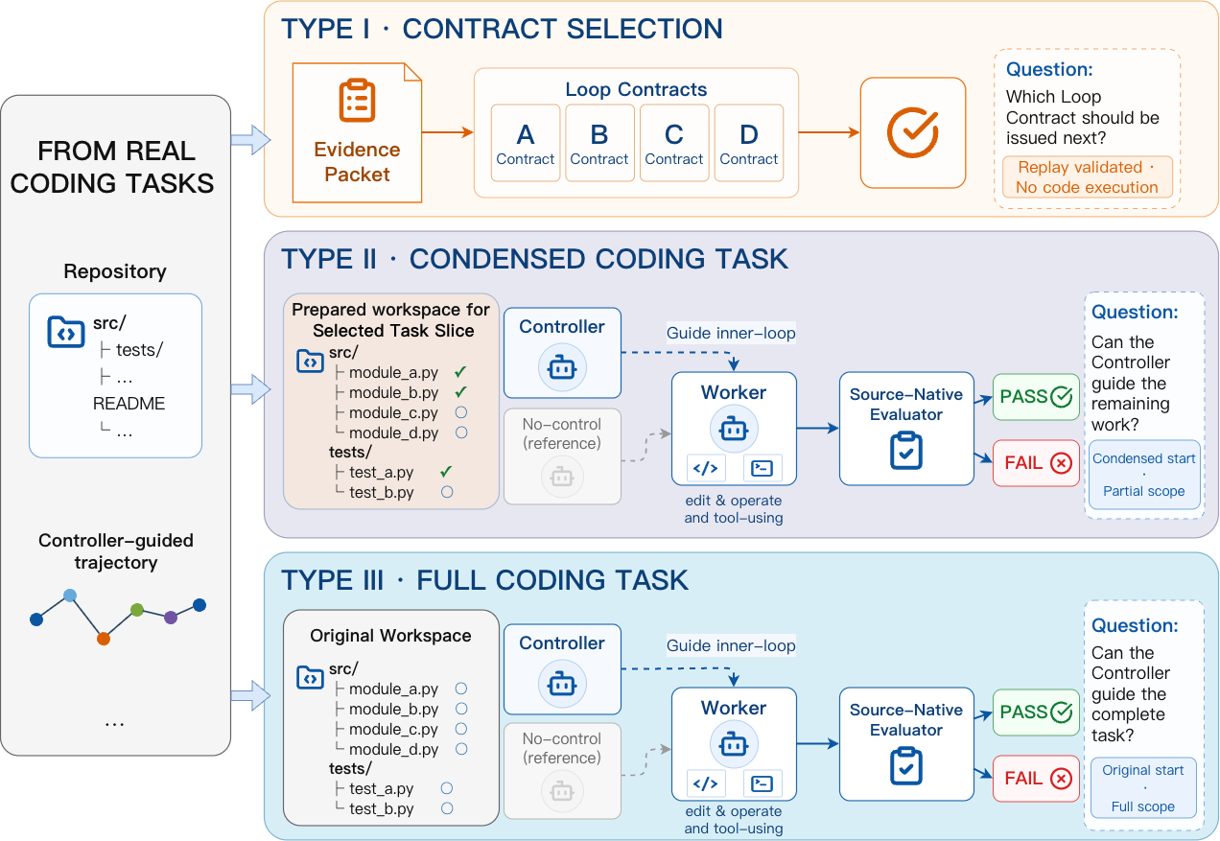
Figure 2. The three LoopArena settings. Type III evaluates a full coding task from its original state. Type II starts from a prepared intermediate workspace and evaluates one slice of the same task at lower cost. Type I takes a restorable control point and determines the correct answer by replaying all four candidate Loop Contracts once, during construction — so scoring a new Controller later is a no-execution, four-way choice.
The three scopes climb in cost and realism. Type I is a single decision: at one control point, choose the best of four candidate Loop Contracts. The expensive part — replaying all four contracts to see which is correct — is done once during benchmark construction, so evaluating a new model is just a four-way choice with no Worker execution. Type II is repeated closed-loop control over a prepared task slice. Type III is the real thing: repeated control over the full task from its original state. Crucially, Type II and Type III are paired on the same tasks, which lets the authors ask whether the cheap slice can stand in for the expensive full run.

What the numbers say
The headline is sobering. On full tasks (Type III), the best Controller — GPT-5.5 — reaches a Strict Success Rate of just 24.69%, and across all evaluated Controllers the range runs from 16.05% to 24.69%. In other words, even the strongest model steers a long coding run to a clean success only about one time in four. Runtime loop control is far from solved.
The more encouraging result is about measurement cost. The cheap Type II slice reproduces almost the same ranking of Controllers as the full Type III task, with a Spearman rank correlation of ρ = 0.9747 under the main scoring criterion — while cutting estimated inference cost by an average of 64.4%. If you mainly want to know which model controls better, the slice gives you nearly the same answer for roughly a third of the cost.
Table 1. Main results (from the paper's Table 2). Type I is Contract Accuracy; Type II and Type III report Strict Success Rate. Reference policies (no-control, fixed-control) are not ranked.
Method | Type I Acc. (%) | Type II SSR (%) | Type III SSR (%)
No control (ref.) | — | 39.51 | 18.52
Fixed control (ref.) | — | 46.91 | 18.52
Qwen3.7-Plus | 72.22 | 48.15 | 23.46
DeepSeek-V4-Flash | 77.78 | 45.68 | 19.75
GLM 5.2 | 74.44 | 37.04 | 16.05
GPT-5.5 | 87.78 | 51.85 | 24.69
Claude Opus 4.8 | 76.67 | 48.15 | 20.99

Restating the goal isn't enough
The two reference policies make the point vivid. A no-control baseline lets the Worker run on its own; a fixed-control baseline simply restates the original goal at every control point. Fixed control does help on the bounded slice, lifting Type II success from 39.51% to 46.91%. But on the full task it collapses back to the no-control level — 18.52%, identical to running with no guidance at all.
That contrast is the paper's cleanest lesson. Persistent goal restatement is not what separates good controllers on long tasks; adaptive, evidence-grounded guidance is. A useful controller has to read the changing evidence and adjust — implement, verify, recover, or stop — rather than repeat the same instruction. There's a second cautionary note too: single-decision Type I accuracy (GPT-5.5 tops it at 87.78%) does not fully predict multi-round success, which is precisely why LoopArena evaluates control at several scopes instead of one.

Why it matters, and what it doesn't settle
LoopArena's contribution is to turn a fuzzy, hard-to-attribute ability — runtime loop control — into something you can measure on its own, by fixing the Worker and varying only the Controller. Its main finding is a reality check: the models we lean on to orchestrate long coding runs are, for now, succeeding only about a quarter of the time. Its practical gift is a cheaper yardstick — the Type II slice — that preserves the model ranking at roughly a third of the cost, giving the community an affordable way to track progress.
The usual caveats apply. The numbers come from a fixed Worker and a specific set of tasks drawn from SCBench and BeyondSWE, so absolute success rates should be read as a snapshot of these conditions rather than a universal ceiling. The strong Type II–Type III correlation is measured over the set of Controllers evaluated here, under one main scoring criterion. But the framing is what lasts: if loop engineering is going to be a serious discipline, the quality of the loop's decisions has to be measurable apart from the agent it drives, and LoopArena offers a concrete, reusable way to begin doing exactly that.

