StudentSim: Training a Personal AI Learning Simulator for Every Student
A framework from Microsoft Research and UIUC that turns sparse per-student records into simulators that both behave like the learner and respond correctly to a tutor's guidance
It is tempting to think an AI tutor gets better mainly by getting smarter — answering more questions correctly. But what actually makes a tutor useful is whether it can adapt to each student: knowing who is stuck where, and which explanation works for whom. Learning that requires feedback from real learners, and that signal is sparse, slow, and costly to collect. Recruiting and tracking a diverse student population to train a tutor is prohibitively expensive, which is a big reason adaptive tutors lag behind advances in the underlying language models.
A new paper from Microsoft Research and the University of Illinois Urbana-Champaign, StudentSim, proposes a different route. Instead of gathering expensive human feedback, it trains a dedicated 'student simulator' for each learner — a model that supplies trainable feedback on a machine's timescale in place of a real student. The catch is that a genuinely useful student simulator needs two abilities at once, and prior methods each delivered only one.
The paper formalizes these two abilities as an optimizable target. Behavioral fidelity (F) means that, without help, the simulator reproduces a student's own response — including that student's characteristic mistakes and strengths. Guidance responsiveness (R) means that, after reading a tutor's guidance, the simulator revises its answer in the direction the guidance points. This F/R decomposition is precisely what turns 'simulate a student' from a vague goal into an objective you can optimize.
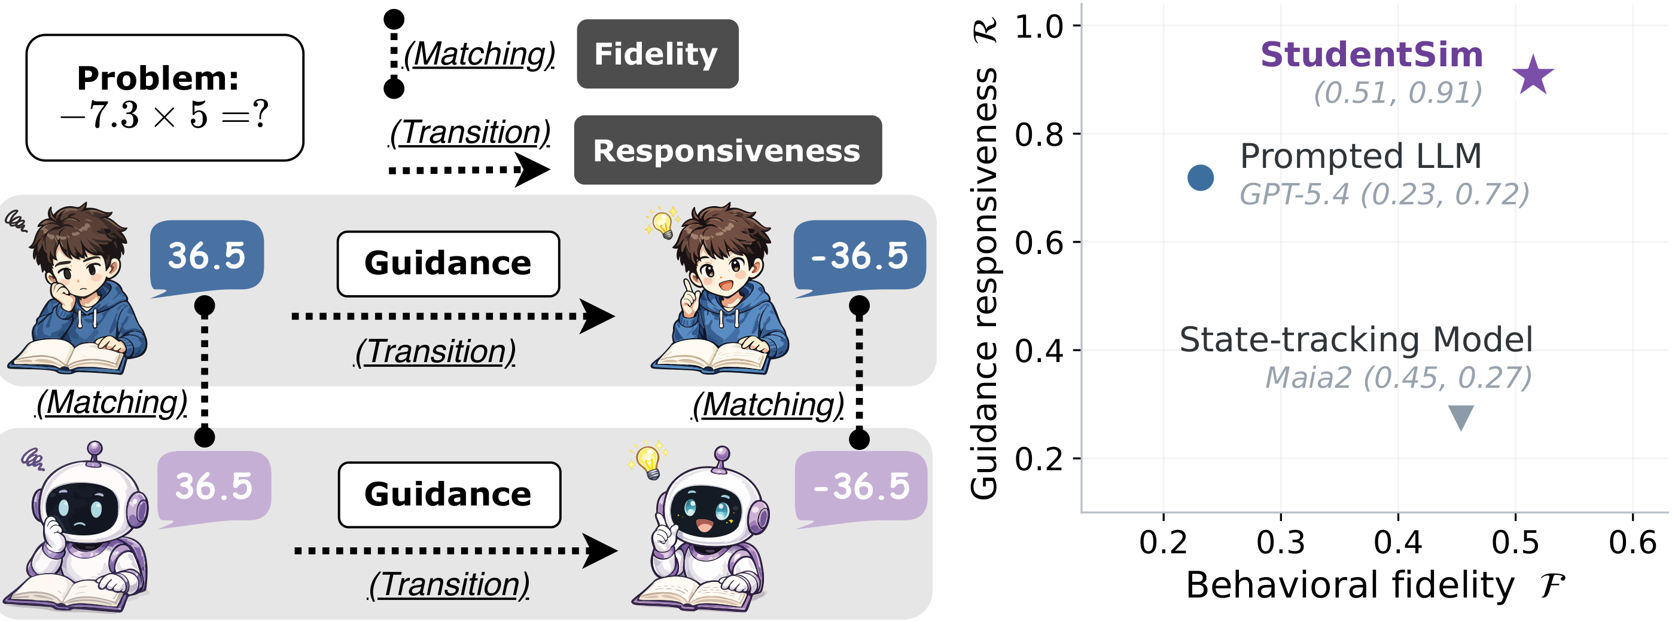
Figure 1. Scoring a student simulator. Educational measurement tracks two signals: what a learner produces independently, and how far they advance once support arrives (the 'zone of proximal development'). A useful simulator needs the matching abilities — behavioral fidelity (behave like the student) and guidance responsiveness (move where the tutor points). On chess (right), StudentSim leads on both axes; the prompted LLM wins responsiveness only, and the state-tracking model wins fidelity only.
Paper: https://arxiv.org/abs/2609.01591 — Code: https://github.com/microsoft/StudentSim

The problem: existing simulators each get only half of it right
Prior student simulators fall into two camps, each stuck at one extreme. The first is state-tracking models — knowledge tracers, or in chess, Maia2, a skill-conditioned, human-style move predictor. They reproduce a student's behavior well but have no channel to digest a tutor's natural-language explanation; however clearly you phrase the guidance, it cannot take it in. The second camp is prompted large language models — for example, prompting GPT-5.4 to role-play a particular student. These follow guidance fluently, but even given a precise description of the student's state, they do not reliably reproduce that specific student's competence and mistakes.
In short, one camp is 'behaves like the student but can't hear the tutor,' and the other is 'hears the tutor but doesn't behave like the student.' Training an AI tutor demands both at once: a simulator that faithfully mirrors a given student and updates correctly under guidance. That gap is exactly what StudentSim sets out to fill.

The method: pool first, then specialize
Per-student records are inherently sparse — one learner leaves far too little data to train a reliable simulator directly. StudentSim resolves this with a two-stage pipeline. Stage 1 pools the sparse records of many students within a domain and trains a single shared 'base simulator' that captures what learners have in common: frequent mistakes, and how they typically revise their answers after guidance. Stage 2 initializes from that base and specializes it using only one student's own records, yielding a 'one model per student' individualized simulator.
The end product is, for each student, a dedicated simulator that both reproduces that student's behavior and updates in the right direction when a tutor intervenes. The pooled base supplies the fidelity groundwork; the per-student specialization supplies responsiveness and individual match. This division of labor matters because neither ingredient works alone: without the shared base, a single student's handful of records is too thin to learn stable behavior from, and without specialization, the base blurs every learner into a domain-average student who resembles no one in particular. Pooling first and specializing second is what lets sparse per-student data go further than it otherwise could.
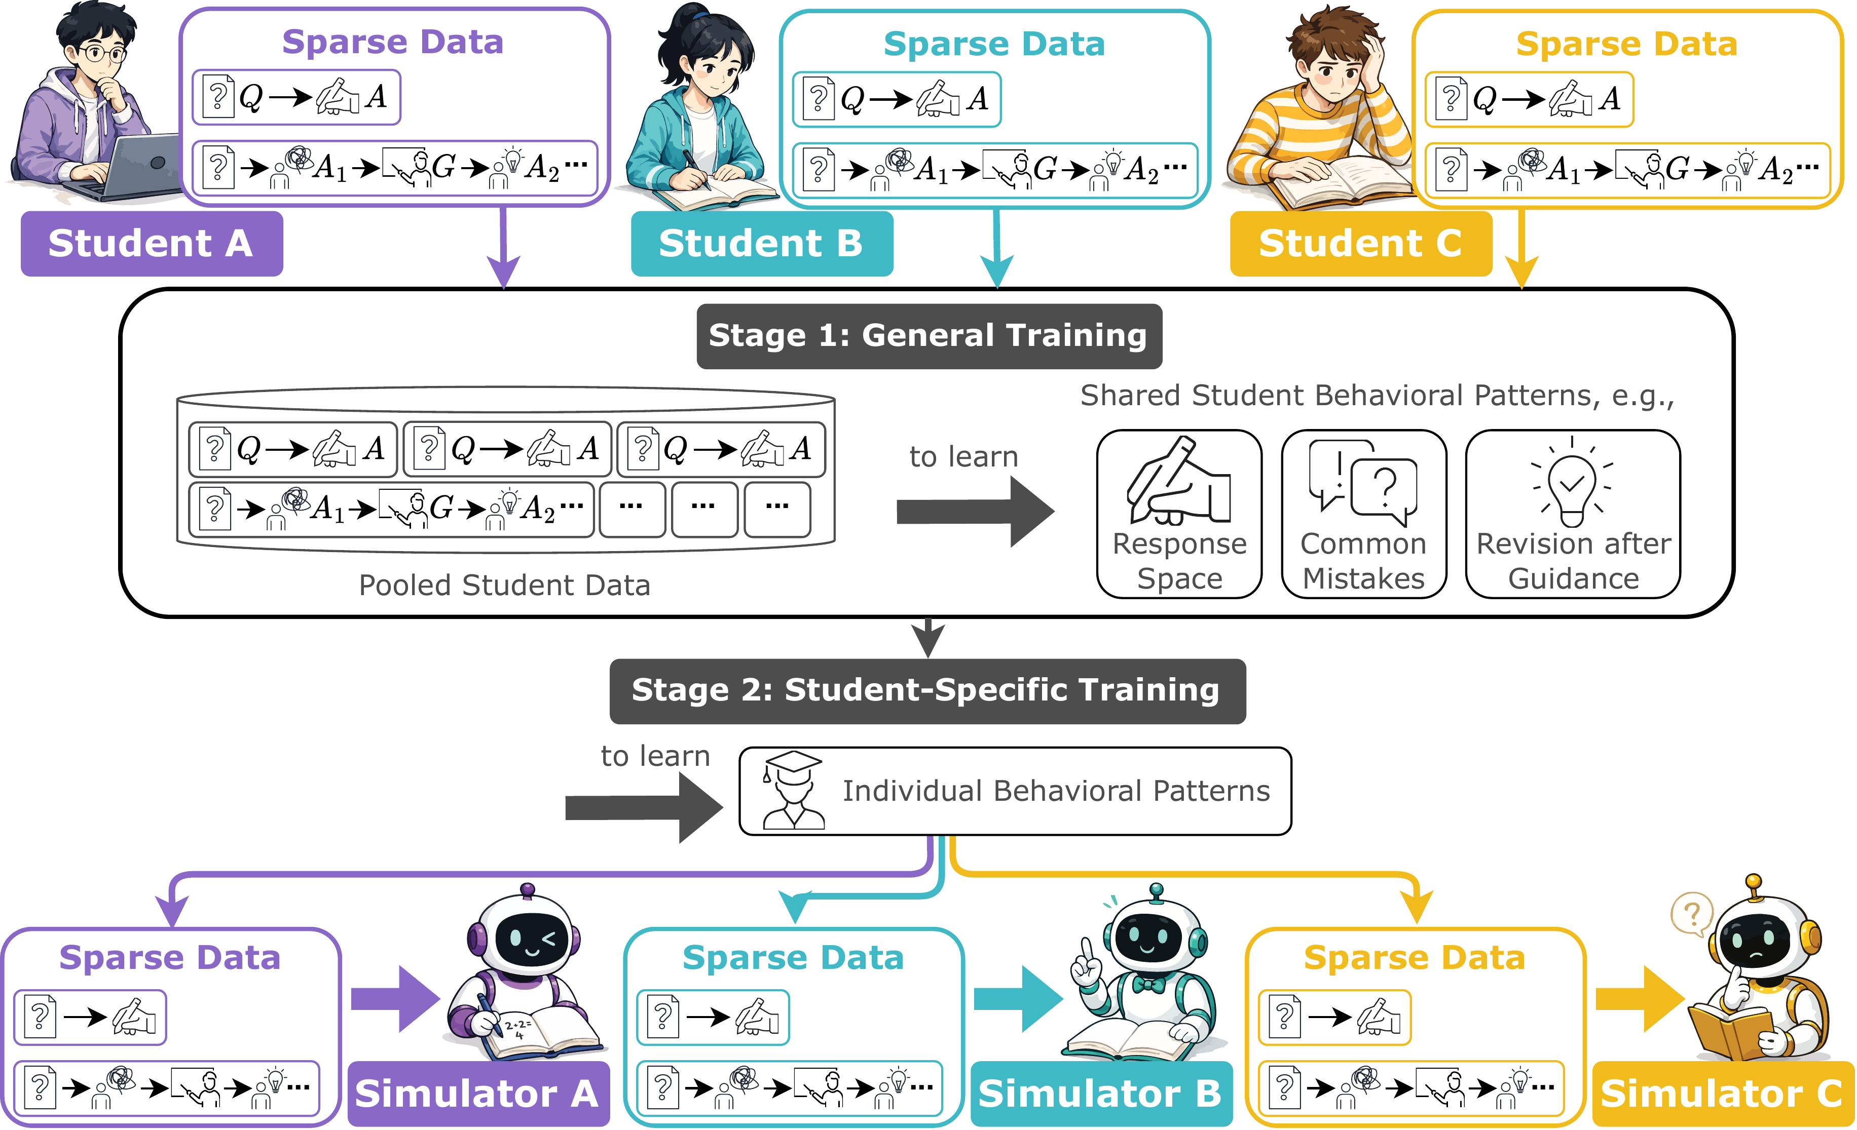
Figure 2. StudentSim's two-stage training pipeline. Stage 1 pools the sparse records of many students in a domain and trains one base simulator on what they share. Stage 2 specializes that base to a single student on that student's own records, producing one simulator per student.

The benchmark: StudentSimEval puts every method on one ruler
To measure the two abilities fairly, the authors built StudentSimEval, a standardized protocol spanning three domains and 60 students total — chess (30 players), second-language English writing (L2, 15 learners), and mathematics (15 students) — drawn from public, de-identified learner corpora. It converts each corpus into a fixed per-student record schema with frozen train and held-out splits, so every method is fit and scored on exactly the same data and the results are directly comparable.
In chess, fidelity F is top-1 accuracy on the student's next move; responsiveness R is the rate at which the simulator, after reading the tutor's guidance, corrects an initial wrong move to the canonical answer. A single held-out position makes this concrete.
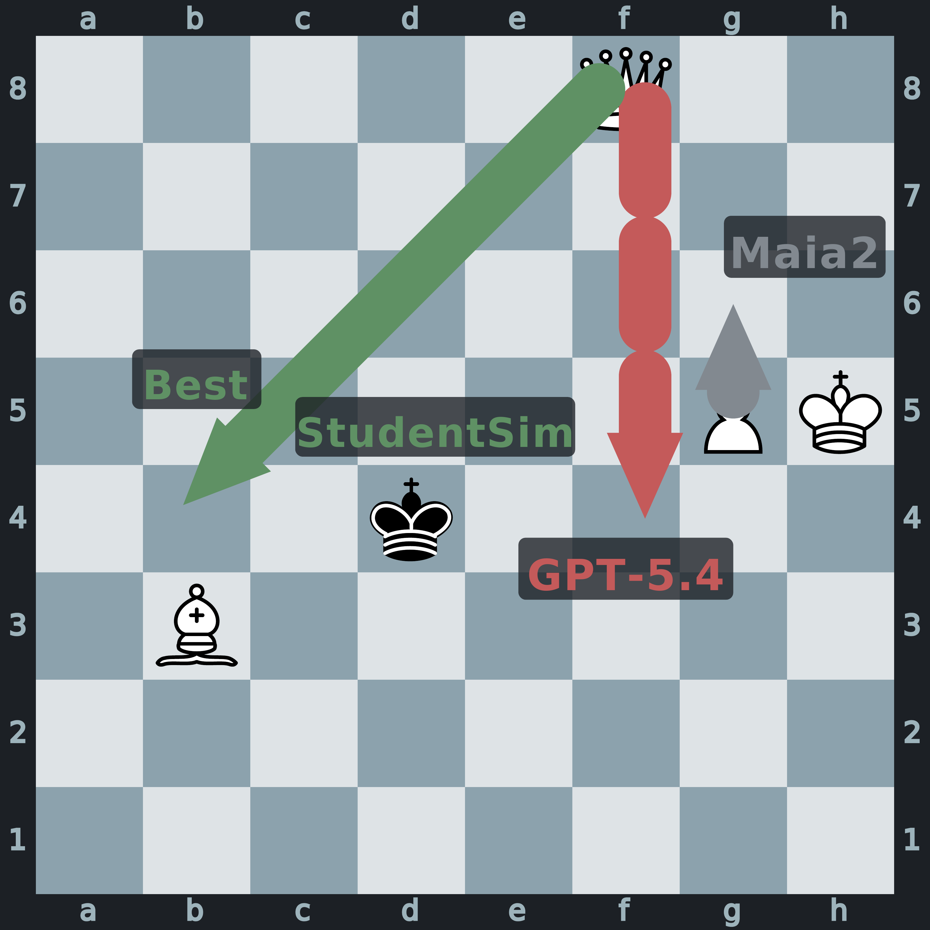
Figure 4. Guidance-following on a held-out chess position. The player blundered with 1.g5g6 (a centipawn loss of 8638), missing a forced queen check on f8b4. The tutor's Socratic prompt only contrasts the pawn push with 'a forcing queen move that gives check from the queenside' — it never names the destination square. Maia2 cannot read the prompt and repeats the blunder; GPT-5.4 reads it but plays a different wrong queen move; StudentSim follows the open-ended guidance and finds f8b4.

The results: ahead on both axes, in all three domains
The core finding is clean: across chess, language, and math, StudentSim's per-student simulators beat GPT-5.4 (a strong closed-source model prompted to role-play students) on behavioral fidelity and guidance responsiveness simultaneously. In chess, StudentSim reaches F=0.51 and R=0.91, versus 0.23/0.72 for GPT-5.4 and 0.45/0.27 for Maia2. Prior methods each win only one axis: GPT-5.4 follows guidance fluently (a fair R) but prompting cannot make it reproduce a particular student's competence (low F); Maia2 has decent fidelity but no way to use natural-language guidance (very low R). StudentSim takes both axes, sitting in the top-right corner of the fidelity–responsiveness plane.
Table 1. Behavioral fidelity (F) and guidance responsiveness (R) by domain (population means; higher is better). The naive baseline is Maia2 for chess and untrained Qwen3-4B-Instruct for L2 and math.
Domain | Metric | Naive baseline | GPT-4o | GPT-5.4 | StudentSim
Chess | F (fidelity) | 0.45 | 0.22 | 0.23 | 0.51
Chess | R (responsiveness) | 0.27 | 0.77 | 0.72 | 0.91
L2 writing | F (fidelity) | 0.51 | 0.47 | 0.51 | 0.56
L2 writing | R (responsiveness) | 0.02 | 0.39 | 0.60 | 0.64
Math | F (fidelity) | 0.49 | 0.51 | 0.61 | 0.64
Math | R (responsiveness) | 0.61 | 0.69 | 0.71 | 0.92
Ablations confirm that both stages are necessary. Removing Stage 1's pooled pretraining, or Stage 2's per-student specialization, each degrades one axis — the simulator collapses back toward the single-axis behavior of prior baselines. Pooled pretraining grounds fidelity through shared domain behavior; per-student specialization supplies responsiveness and individual match. Together they occupy the top-right corner that competing methods cannot reach.

Going further: a simulator reward really does train a better tutor
The authors add a proof of concept: use a frozen StudentSim simulator as the reward source in reinforcement learning (RL) to train a chess tutor. Each episode replays a real student's wrong answer; the tutor policy proposes guidance; the frozen simulator revises accordingly; and the improvement in move quality becomes the reward that drives the RL update. In expert human evaluation, a tutor trained with a StudentSim reward is judged more accurate, better-guided, and more personalized than both a no-RL baseline and a tutor trained against a GPT-5.4 reward.
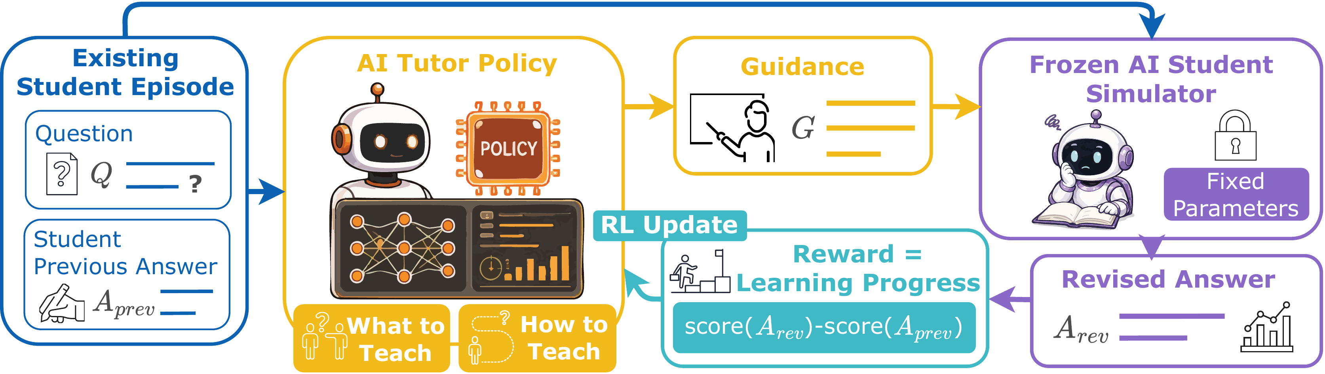
Figure 5. Tutor RL with a frozen student simulator as the reward source. Each episode replays a real student's wrong answer, the tutor policy proposes guidance, the frozen simulator revises, and the improvement in move quality drives the RL update.

Takeaways and limitations
StudentSim's message is that a pool-then-specialize pipeline makes sparse per-student data enough to build simulators that are both faithful to a learner and responsive to a tutor. That joint capability turns student simulation into an optimizable objective, and the RL proof of concept shows it can drive real tutor improvement. StudentSim (the training method) and StudentSimEval (a 60-student benchmark with released code) give the community a shared, extensible way to score and build such simulators.
In fairness, the validation is limited to three domains and 60 students, and the tutor RL is a chess-only proof of concept rather than evidence of large-scale deployment. Only chess has a domain-specific behavior model (Maia2) to serve as a strong baseline; for L2 and math, closed-source LLMs stand in as the strongest available reference. These are the points to keep testing as the framework is pushed toward broader subjects.

